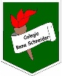

Colegio René Schneider Chereau Teacher: Paula Sepúlveda Millán

Rancagua paula.sepulveda@colegio-reneschneider

Asignature English

**4 ° FOURTH GRADE**

|  |  |
| --- | --- |
| Name: | Date: March, 2020 |
| Goal: Conocer y ascoiar vocabulario referente a las partes del cuerpo | Unit 1: HOW DO YOU FEEL? |

1. Read the following rhyme. (Lee la siguiente rima) puedes verla en el siguiente link y aprenderla: https://youtu.be/Dcnmbnhq_Zk

Two little **eyes** to look around

Two little **ears** to hear each sound

One little **nose**  to smell what’s sweet

One little **mouth** that likes to eat

2.Copy the parts of the face, use the words from the box. (copia las partes de la cara, usa las palabras del recuadro). Pintar”optativo”

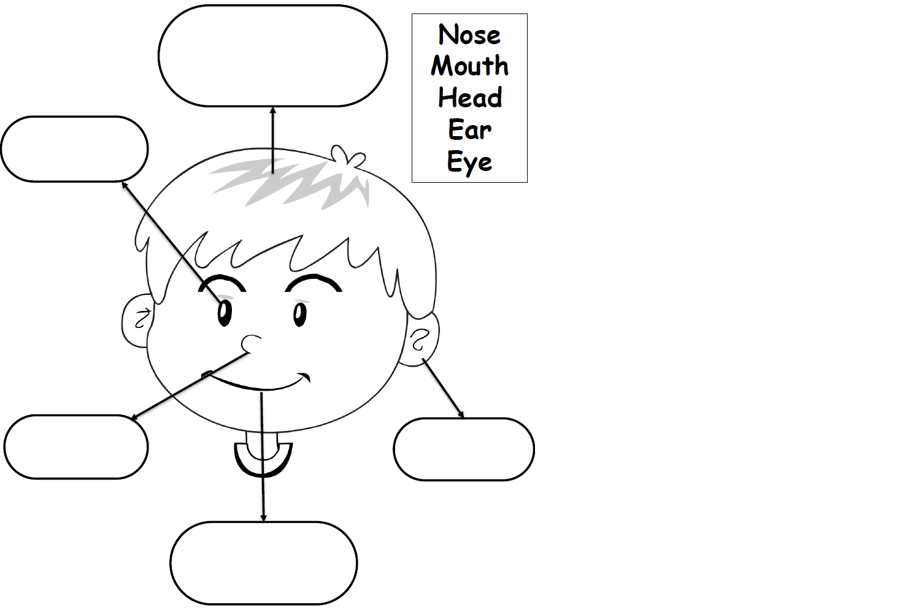

3. Look at the picture and complete with the missing letters. (Observa la imagen y completa palabra con las letras que faltan).

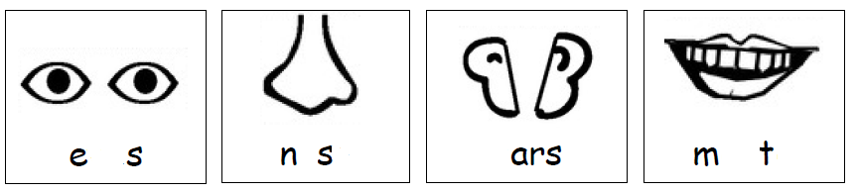

----- --- --- --- ------ ---

4. Look at the pictures and complete the sentences with the correct word.(observa imágenes y completa las oraciones



1.These are my ____________________



2. This is my ______________________



3. These are my ___________________



4. This is my ___________________

5. Listen to the song “ head and shoulders:::” in the following link. (Escucha la canción cabeza, hombros… en el siguiente link)

https://youtu.be/WX8HmogNyCY