**GUÍA DE KINESIOLOGÍA**

|  |  |
| --- | --- |
| **Asignatura – Módulo** | : Taller de kinesiología |
| **Profesional Responsable** | : Kinesiólogo Rodrigo Rivera |
| **Correo electrónico** | : [rodrigo.rivera@colegio-reneschneider.cl](mailto:rodrigo.rivera@colegio-reneschneider.cl) |
| **Curso - Nivel** | : Sexto Básico |

|  |  |
| --- | --- |
| **Objetivo** | : Realizar las siguientes actividades de grafomotricidad |
| **Instrucciones** | : Repasar los trazos en figuras, líneas y pintar. |

**PINTA DE COLOR VERDE LOS PERRITOS QUE MIREN HACIA EL LADO DERECHO Y DE COLOR AMARILLO LOS PERRITOS QUE MIREN HACIA EL LADO IZQUIERDO.**

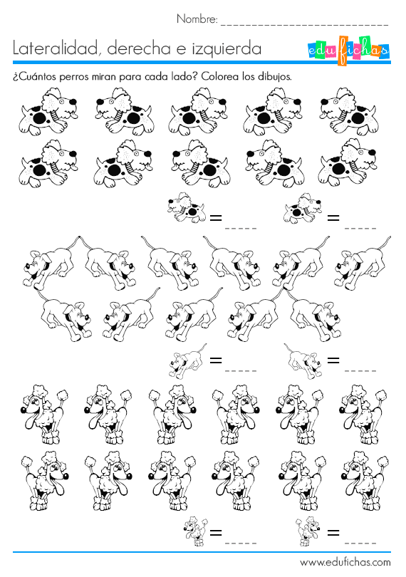

**¿CUANTOS PERRITOS MIRAN HACIA EL LADO DERECHO? ___________________**

**¿CUANTOS PERRITOS MIRAN HACIA EL LADO IZQUIERDO? __________________**

**REPASA LAS SIGUIENTES LINEAS PARA COMPLETAR LA FIGURA, LUEGO PINTALA Y REALIZA LAS SIGUIENTES ACTIVIDADES.**

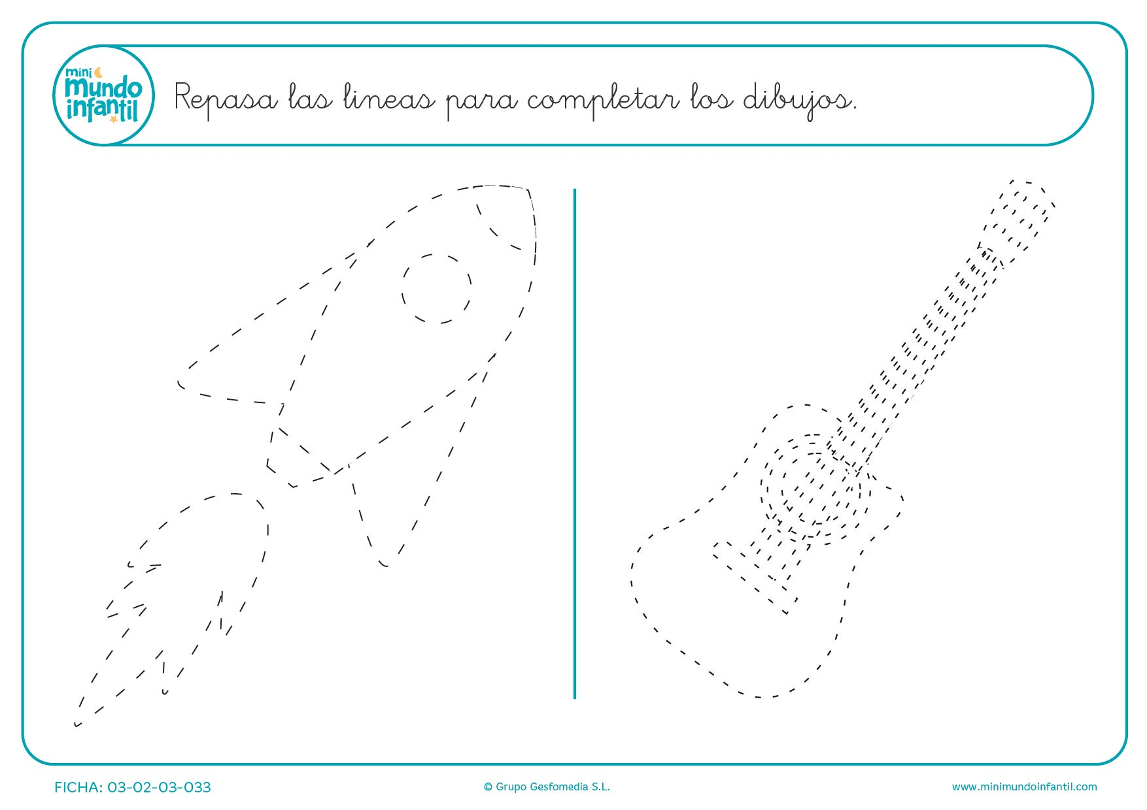

**¿Qué se ve en el dibujo? En 5 líneas escribe con letra manuscrita una historia relacionada con lo que se ve en la imagen.**

________________________________________________________________________________________________________________________________________________________________________________________________________________________________________________________________________________________________________________________________________________________________________________________________________________

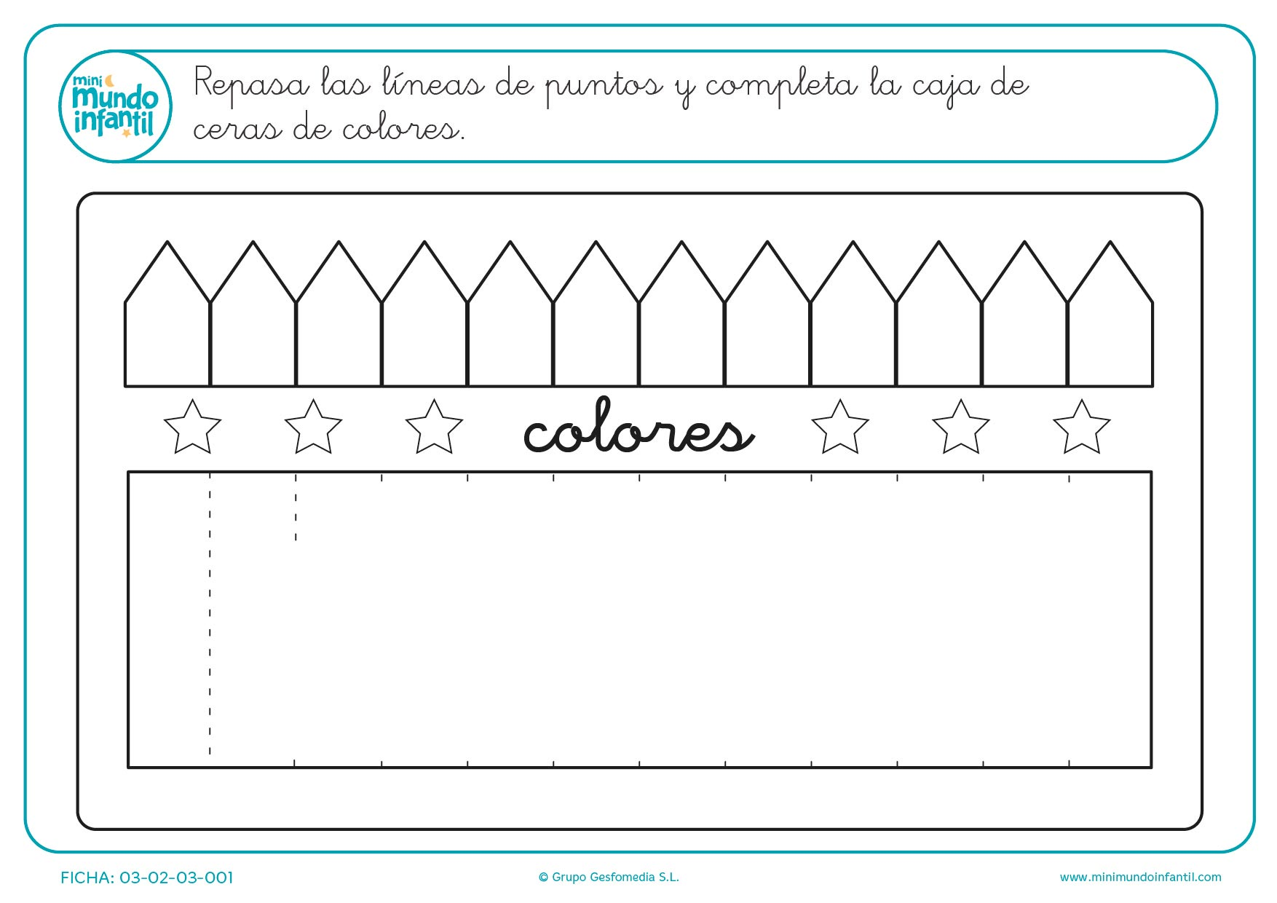**REPASA LAS LINEAS DE PUNTOS Y COMPLETA LA CAJA CON LAPICES DE COLORES.**

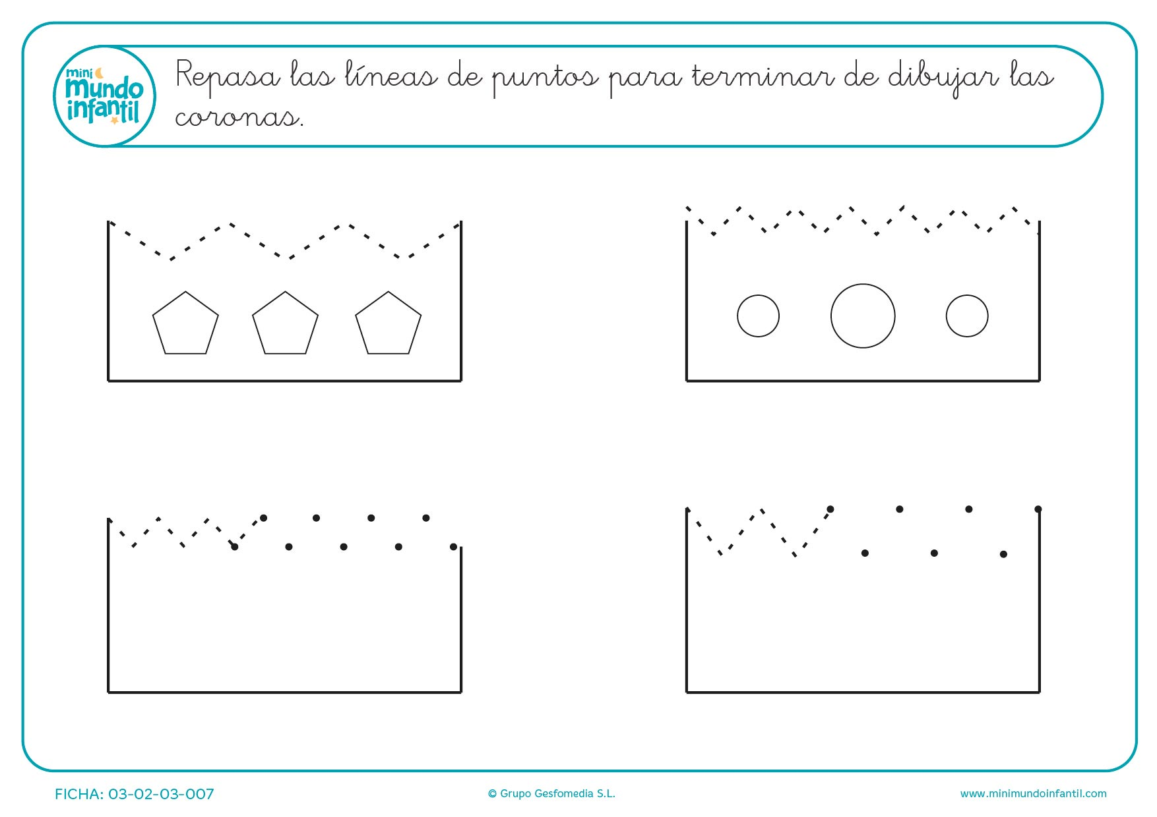**REPASA LAS LINEAS PARA COMPLETAR LAS CORONAS**

**ESCRIBE UN CUENTO EN 20 LINEAS, UTILIZANDO LETRA IMPRENTA**

**____________________________________________________________________________________________________________________________________________________________________________________________________________________________________________________________________________________________________________________________________________________________________________________________________________________________________________________________________________________________________________________________________________________________________________________________________________________________________________________________________________________________________________________________________________________________________________________________________________________________________________________________________________________________________________________________________________________________________________________________________________________________________________________________________________________________________________________________________________________________________________________________________________________________________________________________________________________________________________________________________________________________________________________________________________________________________________________________________________________________________________________**

**REALIZA UN DIBUJO RELACIONADO CON TU HISTORIA.**

**ESCRIBE UNA CARTA QUE HABLE SOBRE TI, Y LAS COSAS QUE MAS TE GUSTA HACER CON TU FAMILIA. EN 20 LINEAS, UTILIZANDO LETRA MANUSCRITA.**

**____________________________________________________________________________________________________________________________________________________________________________________________________________________________________________________________________________________________________________________________________________________________________________________________________________________________________________________________________________________________________________________________________________________________________________________________________________________________________________________________________________________________________________________________________________________________________________________________________________________________________________________________________________________________________________________________________________________________________________________________________________________________________________________________________________________________________________________________________________________________________________________________________________________________________________________________________________________________________________________________________________________________________________________________________________________________________________________________________________________________________________________**

**REALIZA UN DIBUJO RELACIONADO CON TU HISTORIA.**

**AYUDA AL PITUFO A LLEGAR A SU CASA**

