**Guía n°7 “Porcentajes”**

**Asignatura:** Matemática  **Curso:** Sexto básico

**Fecha:** 11 al 15 de mayo 2020 **Docente:** Virginia Ávila Retamal

**Nombre del Alumno:**

**I.- Objetivo de Aprendizaje:**

**OA 04** Demostrar que comprenden el concepto de porcentaje de manera concreta, pictórica y simbólica, de forma manual y/o usando software educativo

**II.- Contenido: Porcentajes**

**III.- Objetivo de la clase:** Representar porcentajes

**IV.- Indicaciones generales**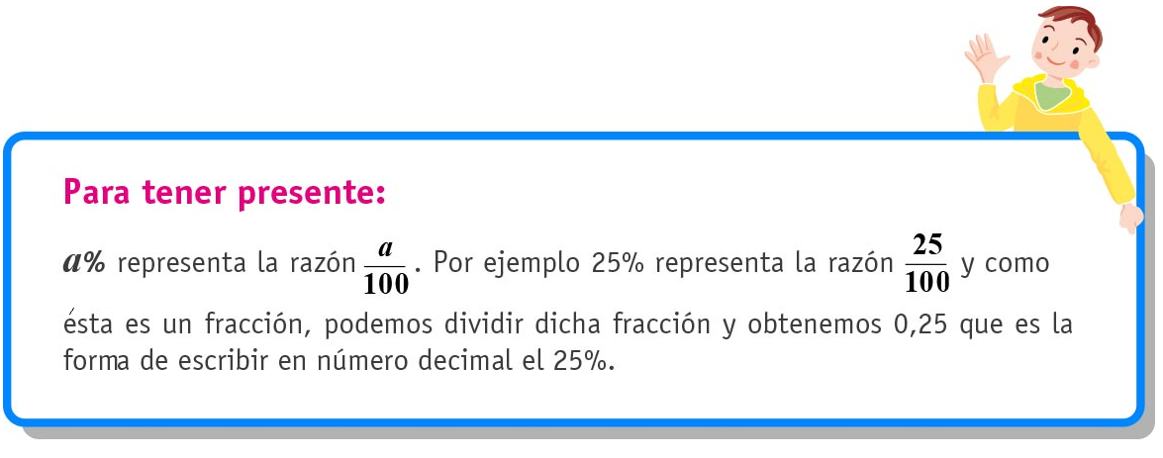

**V.- Actividad a desarrollar**

**Representación de porcentajes**

1. En las siguientes cuadrículas represente los porcentajes indicados, además escríbalos en su representación decimal y como razón.

Ejemplo :

1. 25% Razón Decimal

|  |  |  |  |  |  |  |  |  |  |
| --- | --- | --- | --- | --- | --- | --- | --- | --- | --- |
|  |  |  |  |  |  |  |  |  |  |
|  |  |  |  |  |  |  |  |  |  |
|  |  |  |  |  |  |  |  |  |  |
|  |  |  |  |  |  |  |  |  |  |
|  |  |  |  |  |  |  |  |  |  |
|  |  |  |  |  |  |  |  |  |  |
|  |  |  |  |  |  |  |  |  |  |
|  |  |  |  |  |  |  |  |  |  |
|  |  |  |  |  |  |  |  |  |  |
|  |  |  |  |  |  |  |  |  |  |





1. 35% Razón Decimal

|  |  |  |  |  |  |  |  |  |  |
| --- | --- | --- | --- | --- | --- | --- | --- | --- | --- |
|  |  |  |  |  |  |  |  |  |  |
|  |  |  |  |  |  |  |  |  |  |
|  |  |  |  |  |  |  |  |  |  |
|  |  |  |  |  |  |  |  |  |  |
|  |  |  |  |  |  |  |  |  |  |
|  |  |  |  |  |  |  |  |  |  |
|  |  |  |  |  |  |  |  |  |  |
|  |  |  |  |  |  |  |  |  |  |
|  |  |  |  |  |  |  |  |  |  |
|  |  |  |  |  |  |  |  |  |  |

1. 50% Razón Decimal

|  |  |  |  |  |  |  |  |  |  |
| --- | --- | --- | --- | --- | --- | --- | --- | --- | --- |
|  |  |  |  |  |  |  |  |  |  |
|  |  |  |  |  |  |  |  |  |  |
|  |  |  |  |  |  |  |  |  |  |
|  |  |  |  |  |  |  |  |  |  |
|  |  |  |  |  |  |  |  |  |  |
|  |  |  |  |  |  |  |  |  |  |
|  |  |  |  |  |  |  |  |  |  |
|  |  |  |  |  |  |  |  |  |  |
|  |  |  |  |  |  |  |  |  |  |
|  |  |  |  |  |  |  |  |  |  |

1. 75% Razón Decimal

|  |  |  |  |  |  |  |  |  |  |
| --- | --- | --- | --- | --- | --- | --- | --- | --- | --- |
|  |  |  |  |  |  |  |  |  |  |
|  |  |  |  |  |  |  |  |  |  |
|  |  |  |  |  |  |  |  |  |  |
|  |  |  |  |  |  |  |  |  |  |
|  |  |  |  |  |  |  |  |  |  |
|  |  |  |  |  |  |  |  |  |  |
|  |  |  |  |  |  |  |  |  |  |
|  |  |  |  |  |  |  |  |  |  |
|  |  |  |  |  |  |  |  |  |  |
|  |  |  |  |  |  |  |  |  |  |

**Elaborado por** Paola Ramírez G.

**VI.- Retroalimentación:** Se realizará por mail o de manera presencial los días miércoles de 09:00 a 12:30.

**VII.- Fecha de envío:** Miércoles 20 de mayo hasta las 14:00 PM.

**VIII.- Cómo y/o donde enviar:** Tienes dos formas de entregar, elige la que más te acomode

* Enviar guía o fotos al siguiente correo: pie.avilar@gmail.com
* Entrega en el colegio el día miércoles 20 de mayo.