

Colegio René Schneider Chereau Teacher: Paula Sepúlveda Millán

Rancagua pulita2601@hotmail.com

Asignature English

**8 ° EIGHTH GRADE**

|  |  |
| --- | --- |
| Name: | Date: March, 2020 |
| Goal: OA1: Demostrar comprensión de ideas generales e información explícita en textos orales adaptados y auténticos.  OA2: Identificar palabras y frases clave, vocabulario temático. | Unit 1: “Information and communication technologies” |
| Contenidos: comprensión lectora que contiene vocabulario temático a la unidad con textos simples y adaptados con frases clave relacionadas con el entretenimiento y los medios tecnológicos | Indicadores: .identifican frases  Completan oraciones  Completan información  Asocian según texto leído |

**INSTRUCTIONS:** read carefully and compete.

1. Read about Ana talking about her day at the amusement park. Then, complete the sentences with the word in black. (Lea acerca del día de Ana en el parque de diversiones. Luego complete las oraciones con las palabras ennegrecidas).

*“I want to tell you about my day at the amusement park. My Friends and I went there last Sunday. I* ***love*** *roller coasters, so when I was at the highest point I felt so* ***(2) happy*** *and excited. Susie, one of my friends,* ***(3) hates*** *roller coasters, so she waited for us. Susie* ***(4) likes*** *scary things. She really* ***(5) enjoyed*** *the mystery house. I* ***(6) don’tmind*** *entering the mystery house, but it’s not my* ***(7) favorite****”.*

1.“I ____________ roller coasters”.

2.“When I was at the highest point,I felt ____________and excited”.

3.“Susie____________roller coasters”.

4.“Susie______________scary things”.

5.“Susie really____________the mystery house”.

6.“I_____________entering the mystery house, but it’s not my”____________.

Observe el siguiente recuadro con gramática

Example:

**subject pronuns** “**I** have a cat”

**Possessive adjective** “**my** cat is lazy”

**Possessive pronun** “this cat is **mine”**

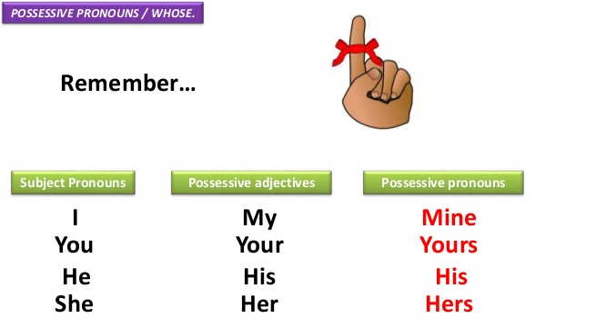

2. Read the sentences and choose the correct possessive adjective for each case. (Lea las oraciones y elija el adjetivo posesivo correcto, mire el recuadro arriba).

1. I’m a high school student. This is …. school.

a) her

b) my

c) their

2. My uncle is a taxi driver. That is …. taxi.

a) her

b) my

c) his

3. My brother and I bought a new PlayStation. It is ….PlayStation.

a) our

b) your

c) their

4. Tom has tickets for the next soccer match. Those are ….tickets.

a) her

b) their

c) his

5. You left your backpack here. This is ….backpack.

a) your

b) his

c) my